1 Old Winery Business Park
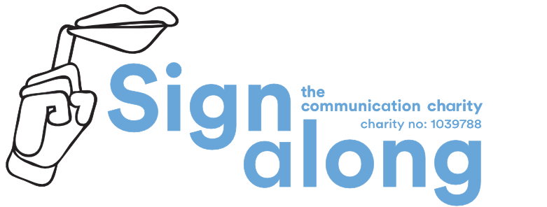
Cawston, Norwich, Norfolk
NR10 4FE
0330 120 0770
business@signalong.org.uk

Licensing of Signs
A Licence gives you the right to print and distribute, within your organisation or establishment, our signs under the terms and conditions as stated in the Licence Agreement Document. This is a Perpetual Licence and will not require renewal. Two copies of the Licence Agreement Document will be sent to you, you must sign both copies and return one copy to us. Please note that no work will commence on your license until payment has been received and turnaround time is usually 15 working days for completion.

Cost
A licence costs £4.00 + VAT per sign. Please note that there is a minimum order charge of £50 +VAT.

Signs-one sign or two?
Each part of speech (e.g. noun, adjective…) counts as 1 sign.
E.g. School dinner counts as 2 signs as “school” is an adjective, and "dinner" is a noun.

New signs
There will be an additional charge of £10.00 +VAT per sign.

New drawings
If you want 2 signs to be combined into 1 sign, there will be a charge of £5.00 +VAT per combined drawing, as the signs have to be re-drawn again to match each other.

Format of signs (Please tick required format)

1) Word Document (default) OR PDF

2) CD (default) OR Memory Stick (additional charge) OR Emailed Direct

Page Layout (how many signs on each page)

9 signs on A4 (default) …… 2 signs on A4 (landscape) …… 4 signs on A5 ……

4 signs on A4 …… 1 sign on A4 …… 1 sign on A5 ……

Estimated number of signs….……………...... Estimated Cost…………+ VAT

Signature ………………………………………………….……. Date………………………………......…...

Please print your name ………………………………………………………………………….............……
1 Old Winery Business Park
Cawston, Norwich, Norfolk
NR10 4FE
0330 120 0770
business@signalong.org.uk

Licensee & Invoice Payer Details

Licensee Details

Name………………………………………...…Establishment/School………………………….........……

Address (for licence)…………………………………………………………………….……..........................

………………………………………………………………………………………………………..........…......

………………………………………………………………………………………………………..........…......

Telephone…………………………….………… Email………………………………......…..

Signature…………………………………….…. Date………………………………......…...

Invoice Details

Order number………………………………………………………………………….........…………………...

Establishment………………………………...… FAO………………………………......…...

Address…………………………………………………………………….…………………………….............

………………………………………………………………………………………………………..........…......

………………………………………………………………………………………………………..........…......

Telephone…………………………….………… Email………………………………......…..

Signature…………………………………….…. Date………………………………......…...

Page….. | Please fill out each column and make sure that words are non-ambiguous.  Please give your word list in the order you would like the signs to appear.
 | Chapter (Optional) | Sign | Context | Part of speech
e.g. | Chapter 1 “Camping” | Light | Torch / Lamp | Noun
e.g. |  | Light | Weight | Adjective
e.g. |  | Light | Not dark | Adjective
e.g. | Chapter 8 “Clothing” | Dress | Item of clothing | Noun
e.g. |  | Dress | Getting dressed | Verb
1
2
3
4
5
6
7
8
9
10
11
12
13
14
15
16
17
18
19
20
21
22
23
24
25
26
27
28
29
30
31
32
33
34
35
36
37
38
39
40
41
42
43
44
45
46
47
48
49
50

